**Our Cool Complaints Policy**



**Developed by Year 4, 5 and 6**

**In November 2016**

**The children in Llanrhidian Primary school believe that a complaint is something you need, but a moan is something you want! Our policy is to address serious issues that are affecting YOU!**

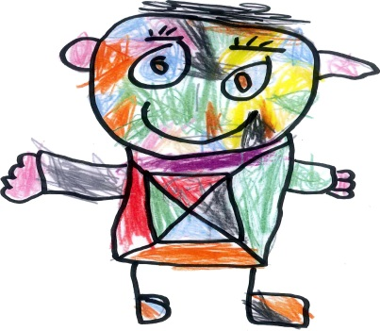

**Cool Complaints**

As pupils we can make a complaint about any matter concerning our school. By law our school must have a procedure for dealing with complaints from many people including parents and pupils.

**Remember…..** A complaint is more than just a moan. A complaint is taken seriously and there are set procedures the school must follow.

**Mrs Caswell is** the school’s designated person to hear pupil complaints.

**Some things you could complain about are:**

* anything about your school life
* the behaviour of an individual(s) – for example another pupil or member of staff
* something that has happened outside school but which is connected to the school – such as the behaviour of pupils on a school bus

These are only some examples. There may be other things you want to complain about.



**Privacy**

All complaints will be kept private. This means that normally it will not be discussed with anyone without our consent. However, there are some circumstances where a complaint has to be shared with other people, especially if it means we are in danger of being hurt. If this is the case this will be explained to you.

**Making a complaint**

When we make a complaint

* everything we say will be listened to,
* we will be asked questions to make things clear,
* we will be dealt with fairly,
* we will be allowed to have someone with us to help if we wish.
* we will be told how our complaint is progressing,
* we will be told the outcome

**Things for us to consider when making a complaint**

* Is our complaint about something which affects the whole school, a group of pupils or an individual pupil? Could we ask the School Council to consider it?
* Could we solve the problem in any other way by talking to our class teacher, teaching assistant or someone else in school?
* If we decide to ask the school council or an individual member of staff to take up the matter but we are not satisfied with the results we can still use this Cool Complaints Procedure.



**Other pupils**

We could be:

* A pupil who is being complained about, or
* a pupil who has seen something happening that is being complained about.

In these situations:

* everything we say will be listened to,
* we will be asked questions to make things clear,
* we will be dealt with fairly,
* we will be allowed to have someone with us to help if you wish

**Remember:**

* Most complaints can be dealt with if we tell someone.
* All complaints made to the school are treated seriously.
* If we make malicious or spiteful complaints that are found to be untrue there may be consequences.

