**Gwasanaeth Nyrsio Ysgol a Plant sy’n Derbyn Gofal**

**School Nursing and Looked After Children Service**

**Welsh Translation**

**Mae dolenni gwe a'r codau QR (Cymraeg a Saesneg) ar gyfer gwefan y Gwasanaeth Nyrsio Ysgolion a Plant sy'n Derbyn Gofal I’w weld isod.**

**Please find below the web links and QR codes (English & Welsh) for the School Nursing and Looked After Children Service website.**

Saesneg/English – website link

<https://sbuhb.nhs.wales/community-primary-care/primary-care/school-nursing-and-looked-after-children-services/>

Cymraeg/Welsh – website link

<https://bipabm.gig.cymru/gofal-cymunedol-sylfaenol/meddygon-teulu-deintyddion-ac-ati/nyrsio-ysgol-a-gwasanaethau-plant-syn-derbyn-gofal/>

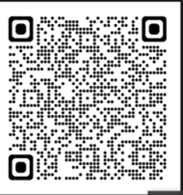 Cod QR Saesneg/English - website QR code

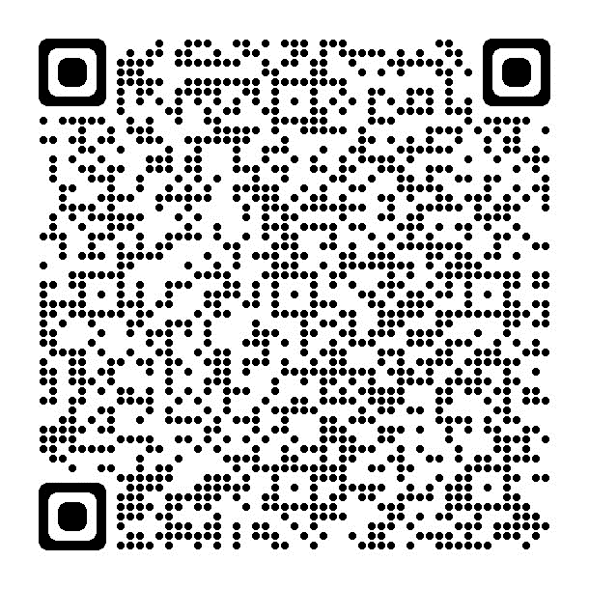 Cod QR Cymraeg/ Welsh - website QR code