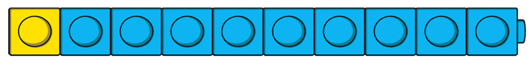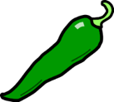

**12 + 7 =**

**15 + 4 =**

**13 + 6 =**

**11 + 8 =**

**10 + 9 =**

**14 + 3 =**

**16 + 2 =**

**18 + 1 =**

**26 + 20 =**

**32 + 30 =**

**41 + 40 =**

**35 + 40 =**

**56 + 20 =**

**44 + 50 =**

**29 + 30 =**

**18 + 20 =**

**Can you make up your own?**

**LO: To add whole numbers using representations.**

**LO: To add to multiples of 10.**

**LO: To add whole numbers to 20.**

**Orange Chilli**

**Yellow Chilli**

**Green Chilli**



**LO: To add whole numbers to a 100.**

**Red Chilli**

**12 + 15 =**

**23 + 14 =**

**34 + 25 =**

**41 + 16 =**

**52 + 17 =**

**11 + 22 =**

**30 + 40 =**

**42 + 36 =**