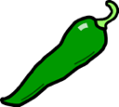

**30 + 20 =**

**32 + 22 =**

**24 + 65 =**

**26 + 53 =**

**18 + 81 =**

**53 + 23 =**

**LO: To Add two-digit numbers**

**LO: To Add two-digit numbers**

**340 + 220 =**

**312 + 272 =**

**204 + 695 =**

**261 + 533 =**

**181 + 501 =**

**233 + 723 =**

**LO: To Add two and three-digit numbers**

**LO: To Add two and three-digit numbers**

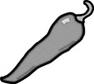

**LO: To Add three-digit numbers**

**41 + 29 =**

**12 + 78 =**

**14 + 56 =**

**63 + 19 =**

**89 + 55 =**

**37 + 68 =**