**WAGOLL**

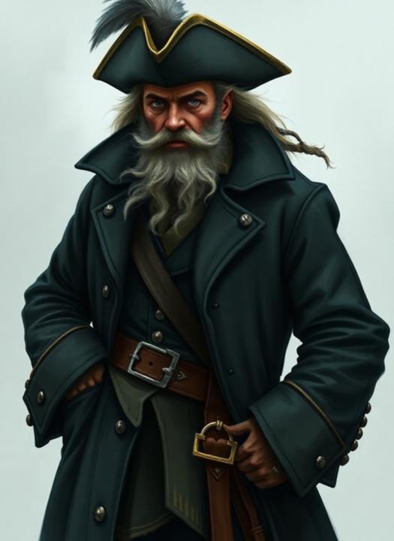

Captain Idris Storm was a **tall** pirate with a **big** **black** hat.  
He had a long coat and shiny boots.  
His beard was wild, and his eyes looked sharp.  
People say he hid treasure in the Gower marsh.  
He carried a magic compass that pointed to secrets.



Captain Idris Storm was a **mysterious** pirate who once sailed the Gower coast.  
He wore a **long**, **dark** coat and a **feathered** hat.  
His beard was tangled like seaweed, and his boots were muddy from the marsh.  
Some say he vanished after hiding a magical compass that can find what your heart wants most.  
He was brave but secretive — no one ever knew what he was really thinking.

Captain Idris Storm was no ordinary pirate — he was a legend of the Gower marshes.  
With a voice like **thunder** and eyes as **sharp** as gull claws, he commanded both fear and curiosity.  
His coat, tattered from years at sea, still carried the scent of salt and smoke.  
Rumours say he vanished into the mist with a magic compass said to reveal your heart’s deepest desire.  
Clever, cunning, and fiercely loyal to his crew, Idris Storm left behind more questions than answers.