1 | 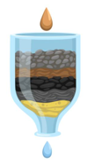  Question:  Which material will filter water the fastest?

2 | Research  I have found out that…  *______________________________________________________  *______________________________________________________  *______________________________________________________

2 | Research  I have found out that…  - The sand has the smallest particles.  - The rocks have big gaps between them.  - Water is cleaned by filtering.

3 | Planning  I will need:  - Water bottle  - Filter paper  - Rubber band  - Sand  - Small rocks

4 | Prediction  I think that the ___________________ will be the quickest because ____________________________________________.

5 | Diagram

6 | Results

7 | Conclusion  I have found that the _______ the particles the ____________the water goes.

