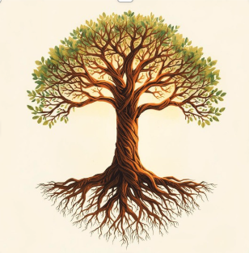
“Our Roots Hold Us Strong”
Our roots hold us strong through each passing day,
We dance in the light of old songs we still sing,
Traditions will guide us, come what may.
The stories of elders will show us the way,
In laughter and feasting, the joy they bring,
Our roots hold us strong through each passing day.
From harvest to winter, in work and in play,
The bells of our customs forever will ring,
Traditions will guide us, come what may.
Though time moves us forward, we choose to stay,
In colours and music, our voices take wing,
Our roots hold us strong through each passing day.
The hands of our loved ones will never betray,
They weave every thread in the songs we sing,
Traditions will guide us, come what may.
Our roots hold us strong through each passing day,
Traditions will guide us, come what may,
In stories and songs that forever will cling,
Our roots hold us strong through each passing day.

