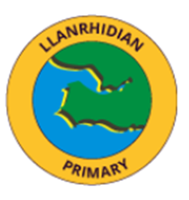
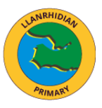
Wales, Our Land of Song
In Cymru, where green hills roll so wide,
With sheep that wander side by side,
Red dragons fly on flags so bright,
A symbol strong of courage and might.
From mountains tall like Snowdon’s peak,
To Llanrhidian village, calm and unique,
Each place we know, both near and far,
Feels like cynefin — home is who we are.
We see each golden daffodil sway,
Brightening fields along the way,
The wind sings softly through each tree,
A land of beauty, proud and free.
We hear the harps, so soft and clear,
And voices singing far and near,
In Welsh and English, loud and true,
A song of friendship shared by you.
With castles old and stories grand,
Of hero’s brave across the land,
Wales shines with history, bold and deep,
A treasure we will always keep.
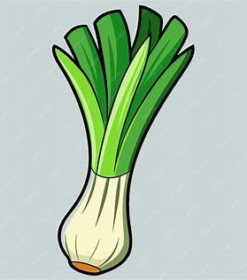
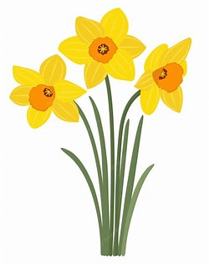
So, here’s to Wales on this special day,
With smiles and songs along the way,
A land of heart, of pride, of cheer —
Happy Welsh Week to all here!

