​
LO:I can combine, change and compare amounts #LlanNum. Harry the scarecrow has created a game using the seeds that he has found in the farmers shed. He has 10 seeds and wants to use them to find different ways to make 10. Can you play his game? How would you record your findings year 1's?
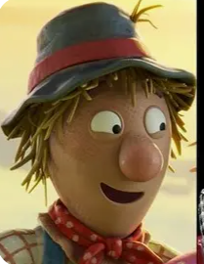

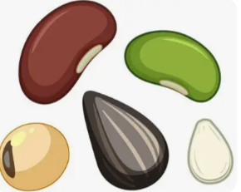
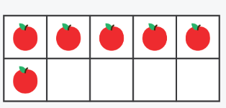

​
LO:I can combine, change and compare amounts #LlanNum. Harry the scarecrow has created a game using the seeds that he has found in the farmers shed. He has 10 seeds and wants to use them to find different ways to make 10. Can you play his game? How would you record your findings year 1's?

​

​
LO:I can combine, change and compare amounts #LlanNum. Harry the scarecrow has created a game using the seeds that he has found in the farmers shed. He has 5 seeds and wants to use them to find different ways to make 5. Can you play his game? How would you record your findings Dosbarth Derbyn?

​
LO:I can combine, change and compare amounts #LlanNum. Harry the scarecrow has created a game using the seeds that he has found in the farmers shed. He has 5 seeds and wants to use them to find different ways to make 5. Can you play his game? How would you record your findings Dosbarth Derbyn?

​

