
​

2. LO:To retell a familiar story with support.To begin to sequence familiar stories. #LlanLit

Miss Jones has forgotten what happens in the story, can you use the colourful sematic cards to retell the story of 'Room on the Broom'?

2. LO:To retell a familiar story with support.To begin to sequence familiar stories. #LlanLit

Miss Jones has forgotten what happens in the story, can you use the colourful sematic cards to retell the story of 'Room on the Broom'?

​

2. LO:To retell a familiar story with support.To begin to sequence familiar stories. #LlanLit

Miss Jones has forgotten what happens in the story, can you use the colourful sematic cards to retell the story of 'Room on the Broom'?

​
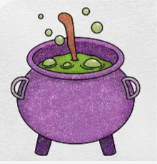
​

1. LO: To use describing words (adjectives) to talk about a character or setting. PS1 #LlanLit

The Witch makes a wonderful broom that carries all the animal friends that she finds. Can you make your own spell? Can you describe the ingredients that you add using 'Wow words'? I wonder what your spell will do?

​

1. LO: To use describing words (adjectives) to talk about a character or setting. PS1 #LlanLit

The Witch makes a wonderful broom that carries all the animal friends that she finds. Can you make your own spell? Can you describe the ingredients that you add using 'Wow words'? I wonder what your spell will do?

